Problem 3:

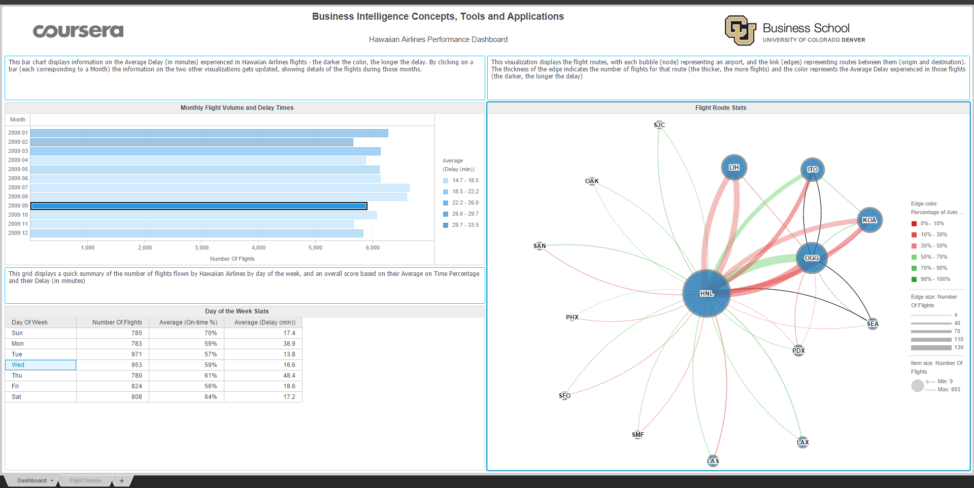

Confidence is 59%

Buffer time is 16.6 minutes